Winter 2017
Volume 2, Issue 2
CDK Independence Times

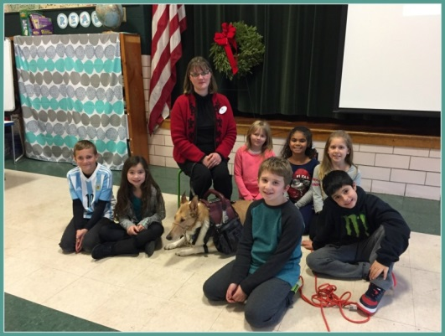
Kristin and Asha at Chapin St. School

Learning about Service Dogs
Copyright © 2017 Chapin Street Elementary

As part of the Empowering Writers program, 3rd grade students at Chapin Street School, in Ludlow MA, are beginning a unit that focuses on service animals. Knowing the importance for the students to have the opportunity to make personal connections to enhance their writing experience, Chapin Street Principal, Mrs. Nikki Reed invited Ms. Kristin Hartness, Executive Director of Canines for Disabled Kids, to speak to the students about how service dogs enhance the lives of many who have a disability.

The presentation began with Hartness introducing herself and her working service dog for 3 ¼ years, Asha, a smooth coat collie. She then asked students if they could tell her the definition of the word disability. Following many thoughtful responses from students, Hartness summarized their answers, “A disability is when your body can’t do certain things. Part of your body doesn’t work the way it’s supposed to work and you may need a little bit of help to do things that others can do without help.”

Hartness shared that her disability is Multiple Sclerosis, which affects her nervous system, making it difficult for her to walk and restricting her independence. She explained, “In addition to helping me walk, Asha also helps me do things I physically can’t do, like pick things up from the floor. He helps me be more independent. I have six legs- two are mine and four belong to Asha.”

Students were fascinated watching Asha work, as he assisted Hartness with picking up a pen from the floor. “This is just one of the many things Asha helps me with throughout the day.”
Hartness explained, “Any place people can go, a person can bring their service dog. A service dog is a tool, just like my eyeglasses are a tool to help me see better. So if someone wearing eyeglasses can go to the movies, grocery stores, restaurants, libraries and fly on an airplane, than so can a service dog.”

Before leaving Hartness reminded students to be respectful of service dogs when they are working. “If you see a service dog always ask permission to pet the dog. You can say- Is your dog working? Can I pet him, please? And if the person says no, it is because the dog is working, and just like when we are solving a math problem, it is important to let him focus and do his work.”

Hartness was pleased with the overwhelming positive reception given to her, and Asha, from the students at Chapin Street School, “Public awareness and education are very important to us. I welcome the opportunity to spread the word about our important work. It’s especially heartwarming when we can spread awareness to students at this young age.”
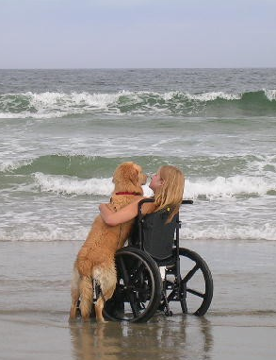
Moving Forward Together - By Erica Way
Twelve years ago I met my best friend, Baker, a beautiful golden retriever who would give me independence in ways that were unimaginable to me at that time. I was 13, shy, and oblivious to what kind of amazing life we would have together. Bumps while navigating through teenage years are inevitable and facing the uncertainty of high school is daunting, but it’s a little more bearable when there’s a furry friend by your side. Because of Baker, the transition to college life was almost seamless. He was my best friend, my confidante. He worked his magic in the dorms and the classrooms with his golden smile, attracting people to us, making it easy to make friends. Baker developed in me a level of confidence I never expected to achieve and this is what allowed me to live a fuller life.
Erica and Baker
After I lost my beloved boy to cancer, I was deeply depressed. It took me many months to accept that I had to go on without him and I struggled to regain some sense of normal. Though I wasn’t sure if I would ever be ready, thoughts of another dog started to cross my mind frequently. Part of me hoped that another dog could help me heal from my tremendous loss and help me move on with my life.
I’ve learned if you always wait until you’re absolutely ready to do something, you’ll be stuck in place, never moving forward. So, I summoned up the courage to apply for another service dog before I was entirely sure I was ready to open my heart again. I expected a lengthy process and was shocked to learn I was matched so quickly. I received an email with a couple of pictures and a few words about a petite black lab named Amberley. By the time I packed my bags for training, my new girl already had a small piece of my heart, though we had never met.
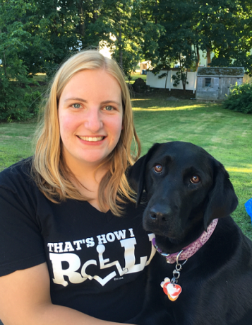
All my doubts, fears, and insecurities vanished the very moment I met Amberley.
Waking up to kisses and a wet nose always starts my day off right. Dropping practically everything I put my hands on, especially when it lands out of reach, is no longer as frustrating as it once was. Though the multitude of tasks that Amberley performs for me on a daily basis are extremely helpful, they only scratch the surface of what makes her so special to me. Any lingering doubt that there would be enough room in my heart for Amberley was laid to rest the day I met her. The bond that formed so quickly between us grows stronger every day. She’s securely nestled in my heart, right next to Baker, and I am no longer stuck in place. I am moving forward, no longer alone.
Erica and Amberley

Editor’s Note: Erica is a former CDK scholarship recipient and was elected to the CDK Board of Directors in 2016
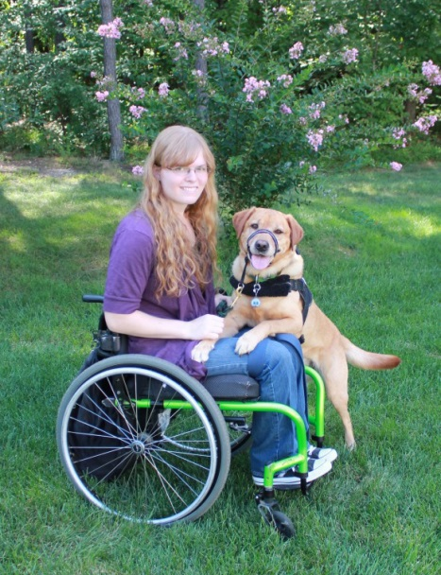
CDK Scholarship Team Receives Award
Last month the AKC® Humane Fund announced the winners of the 17th annual AKC Humane Fund Awards for Canine Excellence (ACE). These awards celebrate five loyal, hard-working dogs that have significantly improved the lives of their owners and communities. One award is presented in each of the following five categories: Uniformed Service K-9, Service, Therapy, Search and Rescue and Exemplary Companion dog
CDK Scholarship recipients Krystal and Teddie received the ACE Award in the service dog category!
Teddie, a five-year-old Labrador Retriever, is the service dog for her owner, Krystal Greco. Krystal suddenly became paralyzed from the waist down at age 14. Unable to attend school regularly, the housebound teenager began feeling depressed, isolated and lonely. Krystal contacted Canine Partners for Life in mid-2012 and Teddie came into her life the following year. Teddie does everything from opening and closing doors to alerting Krystal, who cannot feel anything below the waist, when she might need to use the bathroom. With Teddie’s help, Krystal has earned three college associates degrees, works a part time job, travels and volunteers as a spokesperson and demonstrator for Canine Partners for Life. This fall Teddie will be by Krystal’s side as she begins her baccalaureate degree at Maryland University College
Krystal and Teddie
Congratulations to Krystal and Teddie!

CDK Updates Mission Statement
By Kristin Hartness – Executive Director
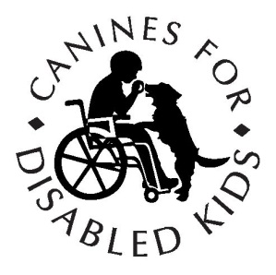
I excited to tell you that we have updated our mission statement to better reflect the work that CDK strives to do. Helping children obtain the perfect service dog for their individual needs; helping families to compare training options to assure they get the training and customer service they deserve; educating communities so that all teams are welcome everywhere – these are the things that drive us.

Canines for Disabled Kids Mission Statement:
To increase independence for children with disabilities and their families through the use of service dogs by creating partnerships, awareness and understanding throughout the community.

Our new mission statement reflects who CDK is and where we are going. Celebrate with me as CDK grows and helps more family’s everyday across the country.

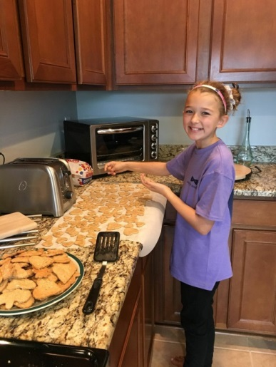
A Truly Amazing Treat
Throughout our lives we are inspired by individuals who do amazing things. One such individual is 10 year old Kira Martin whose initiative, drive and compassion for others are truly amazing!
Kira loves baking, dogs and helping people. She decided to combine these three things into a fundraising project called “Treat” the Disabled. Kira bakes the treats, which contain peanut butter, flour, oats and water, and sells them on her Treat the Disabled Facebook page https://www.facebook.com/treatthedisabled/. There are 12 dog treats in each batch and any donation is accepted. We are thrilled and honored that the money raised by Kira will be donated to CDK
Kira Martin baking treats

CDK’s Mallory Anderson caught up with Kira to find out a little more about her and the Treat the Disabled project. Here is a portion of that discussion:
CDK: Do you have any pets?
Kira: I have a 3 year old yellow lab named Piper.

CDK: What made you decide to do this fundraiser?
Kira: I was inspired by a news article I read at school about a girl who organized a run to raise money for a good cause.

CDK: What ideas did you have?
Kira: I just knew that I wanted to raise money somehow to help kids and dogs.

CDK: How did you choose CDK?
Kira: Well, one thought lead to the other. The thought popped into my head when my dad and I were driving home from school (the same day I read the news article that inspired me). I wanted to help not just kids but also animals. Then that made me think of service dogs. I thought about baking dog treats and selling them to raise money to help kids who need service dogs. After telling my mom what I thought of, we came up with the name “Treat” the Disabled and it was perfect!

CDK: What are your goals for the fundraiser?
Kira: My goal is to continue raising money to help as many disabled kids as I can to afford the service dog they need.

CDK: What has been the hardest part about this?
Kira: Figuring out what kind of cookie cutters to use on the dog treats. I plan to buy one shaped like a dog bone. Right now they are shaped like hearts, butterflies, leaves and carrots.

CDK: Do you have any advice for other kids who would like to raise money for charity?
Kira: Tell everyone what you are doing. You will be surprised at the support you get.

Update: We are happy to report that Kira blew away her original goal and has set a new one for $1,000!! Thanks Kira for all you are doing to increase independence for children with disabilities.
To order your treats or for more information about Kira and Treat the Disabled visit https://www.facebook.com/treatthedisabled/

2016 Holiday Appeal Update
Thank you to all who contributed this year during CDK’s 2016 Holiday Campaign. Your support will help more children realize the independence a service dog can bring by providing them with the ability to do things other kids take for granted.
We have shared a few of the successes your support has provided in this issue of CDK Independent times and we look forward to sharing more throughout the year

Shop for CDK Spotlight
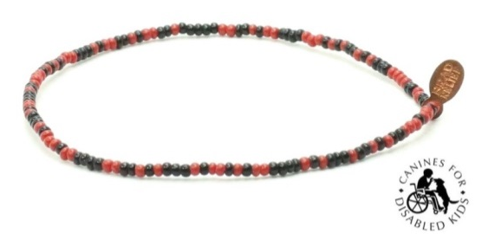
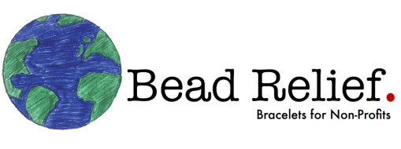
Founded in 2013 by John Gornik and Greg Ellis in Los Angeles, CA, Bead Relief works with charity partners to design a bracelet which uniquely represents their cause. The bracelets are sold on the Bread Relief web site and in retail stores. Bead Relief donates 25% of gross revenue on each and every bracelet sale to the specific charity which the bracelet represents.

Now you can own your very own specially designed CDK bracelet by going to https://beadrelief.com/collections/kids-education/products/canines-for-disabled-kids-bracelet?variant=1033071277
Great Valentine’s Day (or any day) gift idea!
- $6.00 per bracelet
- 25% ($1.50) of your purchase is donated to CDK
- This bracelet was designed by CDK
- 100% waterproof
- Glass seed beads that never fade
- Copper Bead Relief tag
- Bracelets come in three sizes Small, Medium, and Large
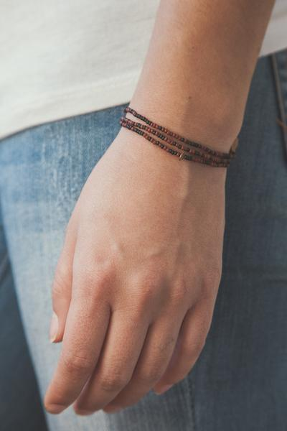

(They look better when you put several together)

CDK Calendar:
Date | Event Name | Location | Description
Feb 1 | Blackstone Girl Scout Troop | St Paul’s Church Blackstone, MA | Educational talk by Barbara and Galley
Feb 8 | Pets and Vets | Providence, RI | Educational talk by Mallory and Jozsi
Feb 19 | Build your own Terrarium | Worcester, MA | Event to benefit CDK at “Seed to Stem”
March 22 | AT Expo | Columbia, SC | Presentation and booth with Kristin and Asha
May 6 | Bridgewater Raritan H.S. Car Show | BRHS, Bridgewater, NJ | Car show to Benefit CDK
May 13 | 2017 Independent Living Expo | Fredericksburg, VA | Presentation and booth with Kristin and Asha
May 24 | Abilities Expo | Chicago, IL | Presentation and booth with Kristin and Asha

For additional information please go to: https://caninesforkids.org/category/events/

