Fall 2017
Volume 3, Issue 1
CDK Independence Times

Meredith and Sami: Stepping Out - Excerpted from a story by Janis Gioia
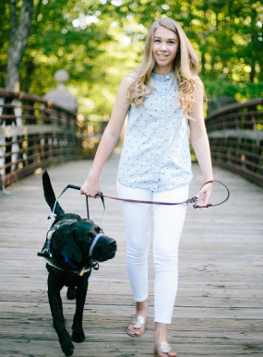
Meredith and Sami
Growing up Meredith loved sports, particularly swimming and basketball. Like most children she dreamt of one day being a star and all that entails.

At age 11 she was diagnosed with Ehlers-Danlos Syndrome (EDS), a genetic disorder which affects connective tissues that support organs, blood vessel walls, skin and bones. The condition can cause mild symptoms, like loose joints and bruising or have life-threatening complications.

For Meredith, EDS causes joint pain and dizziness which sometimes makes it necessary for her to use a wheelchair. She is no longer able to participate in the activities she enjoyed before her diagnosis.

Meredith’s mom, Tracy says, “We never even considered that a service dog could make such a difference in Meredith’s life”. Then, while at an EDS conference with Meredith, Tracy heard a speech by Kristin Hartness, the Executive Director of Canines for Disabled Kids about the amazing things service dogs do.

Intrigued, Tracy and Meredith talked to Kristin after the presentation. “Kristin was instrumental in educating us about everything service dogs,” says Tracy. “How to train one, find one, get one ADI certified…I really knew nothing about the process.” “Kristin helped me get from ground zero to having an excellent understanding of who to talk with, what questions to ask, and how to work with Meredith’s school. Canines for Disabled Kids also provided us with a scholarship to help minimize the cost of acquiring a service dog.”

Tracy says, “Kristin and Canines for Disabled Kids, gave us the confidence and insights we needed to move forward getting a life changing partner for Meredith.”

They found that “life changing partner” in Sami, a tall black lab with the easy-going personality, who Meredith and her family fell in love with immediately. Since Sami arrived, Meredith hasn’t spent any time in a wheelchair. He’s given her the gift of mobility and independence by helping Meredith stay upright and retrieves things Meredith has dropped on the floor, keeping her from getting dizzy bending down.

While Meredith, now 19, may not be able to engage in the sports she loved as a child, she lives independently with Sami, on a beautiful university campus, where she is a sophomore.

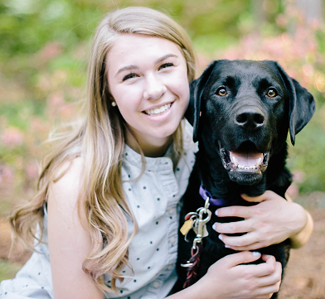
Walking the tree-lined campus is easy with Sami by her side. He attends classes, participates with Meredith in her Student Ambassador Program, and joins Meredith and her friends for pizza on a Friday night.

There’s no telling what they will do next as Meredith focuses on her studies and then life after college. No matter where her career path takes her, Sami will be a constant in her life, making sure she is able to confidently step into her future.
Meredith and Sami

Aimee and Kitsy by Aimee’s mother Jean
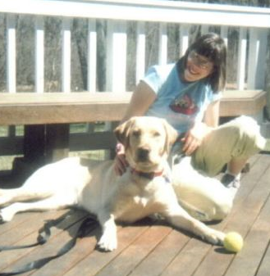
We always knew that having a pet would provide the much-needed companionship that was missing in Aimee’s life. What we didn’t realize was just how profoundly all of our lives would change by having Kitsy join our family. Kitsy is the best friend anyone could ever have. Aimee is truly happy all the time with Kitsy by her side. Aimee has become more confident, social and interactive. We all spend lots of time playing and laughing together. Aimee is thrilled to take Kitsy into our community and tell everyone about her special friend.
Aimee and Kitsy
In addition to helping Aimee with her social skills, Kitsy provides stability and balance to Aimee when she walks in crowds. Our trips to the mall are so much more enjoyable with Kitsy at Aimee’s side. She no longer gets “bumped” and loses her balance. Kitsy makes sure she walks in a straight line and keeps her out of trouble. Kitsy has joined us for several family vacations and even flew to Hilton Head, South Carolina this past April. She was a model service dog and had all the flight staff swooning over her! At home when she’s “off duty” she loves playing ball in the yard with Aimee and loves her long walks with me. She also has several dog friends in the neighborhood. Kitsy visits Aimee at school regularly and has many admirers wherever she goes. When Aimee gets off the bus in the afternoon, Kitsy follows her upstairs to bed. They are a great team!

Our lives have been blessed with the addition of Kitsy to our family. Aimee works so hard at so many things. Her life is full of challenges and difficulties. The friendship and love provided by Kitsy has made an incredible difference in our lives. We will be forever grateful to the organizations that helped bring Kitsy to us.
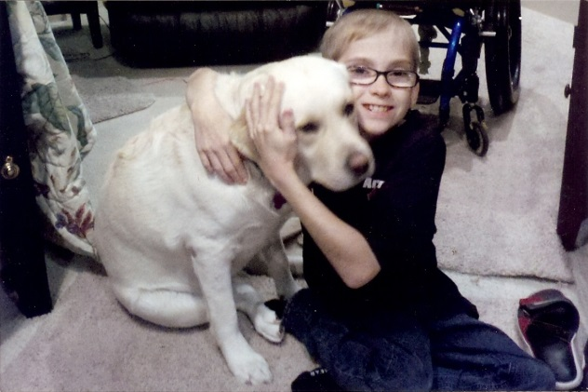
Helping to Fulfill a Dream
Owen and Tori
Owen was eleven years old when he received his scholarship from CDK in 2013. Although Owen was born with Spina Bifida and is confined to a wheelchair he never lets that stop him from swimming, playing with his cat Princess, or coloring. Owen’s favorite place in the world is Ohio because they have amusement parks. Owen’s dream is to one day work at every amusement park around the world. Before Owen received a scholarship from CDK he had abandonment issues and was afraid that he would be left alone with no one to help him. At school he is accompanied by an aid but he was worried that one day the school would stop providing this service. By acquiring a scholarship from CDK Owen was able offset the costs of training his service dog Tori. It also gave Owen greater independence and peace of mind knowing Tori would always be there to help him. Tori helps Owen with a wide range of daily activities like turning the lights on and off, opening and closing doors and picking up items. Hopefully through Owen’s increased independence he can one day travel the world and fulfill his dream of working at every amusement park around the world.

Editor’s Note: In June 2013 CDK received the following message from Sharri Runnels, Executive Director Spina Bifida Association Arizona:
“Hi Kristin,
Just wanted to drop you a line to share with your funders & those who approved the service dog for Owen. He and the dog are at camp this week… it is Owen’s first overnight camp and I am sure it will be a life changer for him. Having the service dog WITH him very likely gave him the added security to make the step to be away from his family and become even more active in his self-advocacy and independence. Thanks to you guys for your part in this!
Sharri”

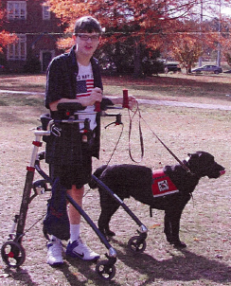
Roger and Dante – An update from Service Dogs of Virginia
Roger and Dante

In the summer of 2014 Robert, a high school freshman with Friedreich’s Ataxia received his constant companion in Dante, a chunky, happy-go-lucky Labrador. While Dante might not think high school is riveting, he gladly accompanies Robert to school, helping him conserve energy by retrieving items and opening doors. As Robert’s parents have observed, Dante has a calming effect on Robert which seems to be helping him focus on his studies, with more A’s and B’s than ever before. Dante allows Robert to be more independent as he doesn’t need to rely on others as much. In addition, Dante has helped Robert socially. When people see Dante, it usually sparks a conversation. This results in Robert interacting with more people who get to experience
Robert’s dry sense of humor, kindness and courage. If you are a fan of the film “Pirates of the Caribbean” you will appreciate Robert’s humor. He thinks the “release” command should be followed by “the Kraken.” He has a point!

CDK Elects New Board President
Kevin Johnson,
CDK Board President
The Board of Directors for Canines for Disabled Kids (CDK) recently elected Kevin Johnson as Board President. Mr. Johnson, a Board Member at CDK since 2008, is a CPA & Manager at O’Connor, Maloney & Co., P.C. in Worcester, MA and was selected a 2017 Top 40 under 40for Central Mass. We caught up with Kevin recently to ask him a few questions:
Q: What attracted you to becoming involved with CDK?
KJ: “I reached a point where I wanted to get involved with an organization. I also want to help disabled kids and I did not realize how helpful service dogs can be.”
Q: How has being a CDK board member impacted you?
KJ: “I have better knowledge and appreciation for service dogs, the ADA, and how it can help people.”
Q: What do you like most about what CDK does?
KJ: “I like that CDK awards scholarships because it helps kids get access to the service dogs they need.”
Q: What would you most like to accomplish during your term as Board President?
KJ: “Hopefully grow the Board of Directors and promote visibility for CDK. “
Q: If you could live at any point in history when would it be and why?
KJ: “Now, I like the advancements in technology and the impact it will have on the future.”
Q: If you could have an endless supply of any food, what would it be?
KJ: “Ice cream, that’s a weakness for me.”

CDK Upcoming Events Calendar:
Date | Event Name | Location | Description
Oct 28 | Bay Area Abilities Expo | San Mateo, CA | Kristin and Asha will be giving a talk
Nov 30 – Dec 1 | Assistive Technology Conference of NE | Crowne Plaza,  Warwick , RI | CDK will have a booth
Dec 2 | DC Metro Abilities Expo | Dulles Expo Center  Chantilly, VA | Kristin and Asha will be going a talk

For additional information please go to: https://caninesforkids.org/category/events/

Kids Helping Kids

Every year Canines for Disabled Kids receives a number of donations from schools, school groups and individual students. These children and young adults raise money by creating and/or participating in a variety of activities in order to support others.

We greatly appreciate each one’s creative thinking, hard work and philanthropic spirit, and thank them for helping to increase independence for children with disabilities through the use of service dogs.

Here are a few recent examples of kids helping kids:
Organization | Activity | Amount Donated
Roger Bryan Elementary School | 3rd grade Hot Chocolate stand inspired by the book “Lemonade War” | $47.00
Clark University – Management100 Students | Laser Tag Outing | $160.00
Suffern High School | Dress Down Friday | $177.00
Dallastown Middle School | Student council donation from selling candy and water for the school’s field day | $300.00
Hudson City School System | 5th grade Lemonade Stand | $57.07
Bridgewater – Raritan Regional School | High School Car Show | $650.00
Francis Howell North High School | Student council male beauty pageant | $125.43
Reid Traditional School’s Painted Rock Academy | 2nd grade winning charity | $40.00
Neisha’s Dance and Music Academy | Dance team event | $1,610.00
A 10 year old girl from SC | Baked and sold dog treats | $500.00
Three young ladies from GA | Made duct tape crafts (purses, wallets, bags) | $146.48

The Priceless Gift of Independence
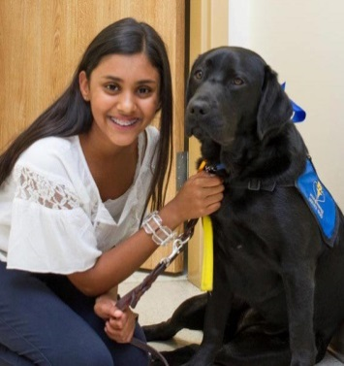
Independence…the freedom to make choices…, to do what you want to do when you want to do it.
For children with disabilities independence comes with four legs and a cold nose. Opening doors, turning on a light, picking up a dropped item or hearing a loved on call your name. These are just a few ways service dogs bring independence to people living with disabilities.
Your support of Canines for Disabled Kids increases independence for children with disabilities, and their families, through the use of service dogs. CDK helps to provide one on one guidance to help families find the right service dog training program for their child's needs, education programs to assist communities be more welcoming and accessible to service teams, as well as scholarships to offset the cost of training a service dog. All programs are offered at no cost to the family or the community.
Madeline and Rialta

