Spring 2017
Volume 2, Issue 3
CDK Independence Times

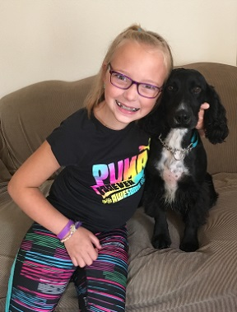
A More Normal Everyday Life
By all accounts, Alyvia is a pretty special little girl with an incredible amount of determination, strength and tolerance for a 10 year old. She shows a lot of empathy for others no matter what their condition and above all always smiles and appreciates life. There are also things Alyvia is not fond of. She does not like doctors and has a lot of anxiety about her normal everyday life as well. She worries about going back to the hospital.
You see Alyvia was born at 26 weeks and as the result of a grade 3 brain bleed developed hydrocephalus (a buildup of fluid on the brain) and epilepsy. She has two shunts to help drain the fluids which have required a number of surgeries to maintain and is part of the reason for Alyvia’s lack of fondness for doctors and hospitals. The bigger issue however, is Alyvia’s seizures resulting from her epilepsy. Although not as frequent as many epileptics; they are severe, ranging anywhere from 25-45 minutes, and normally happen while Alyvia is asleep. Because the seizures are so long, without intervention, there is a risk her body functions may fail putting her life in jeopardy.
Alyvia and service dog Missy
Alyvia’s parents always worry about their daughter. Her mom tells us “I am always tense and scared as her mother. We want to allow Alyvia to become more independent without us always worrying we are going to miss a seizure, especially because they normally have happened in her sleep. We want her to be safe and do not want to wake up one day to find our baby girl dead. She's now at an age where she doesn't like to sleep with mom and dad as much and we can't blame her. I often find myself waking to check the baby monitor to make sure I don't see her seizing in her bed when she's not sleeping with us. Ultimately we want her to be safe and independent.”
After doing some internet research, and working with CDK and Service Dogs for America, Alyvia’s parents were convinced a service dog was the best solution for her daughter. A little over 12 months later Alyvia has a new best friend, Missy, her seizure response dog. Missy alerts another human if Alyvia is having a seizure so that someone can come to her aide
Now Alyvia is able to sleep in her own bed without mom or dad continuously waking up to check on her knowing that Missy will let them know if there is a problem. She is able to step away for a little “alone time”, outside play or other things 10 year olds do. Most of all with Missy’s assistance, Alyvia is now on her way to achieving a greater personal independence and a more normal everyday life.

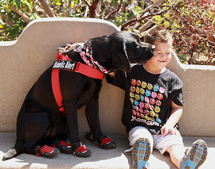
Why Your Gift is So Important!
The founding vision of Canines for Disabled Kids (CDK) is to ensure every child with disabilities, who can benefit from using a service dog, is able to realize their full personal independence with the abilities these incredible animals provide. While service dogs offer assistance with a wide range of challenges, children with disabilities are an underserved segment of those they help. We estimate there are 500,000 school aged children with disabilities in the USA who could benefit from the use of a service dog. Yet according to industry data, approximately 3,000 service dogs are working with this age group today. Said another way, for every child with disabilities who is realizing their full personal independence through the use of a service dog, there are over 165 who are not.
Tristin and diabetic alert dog Roxy
This gap exists because many training programs will only train specific skills for children or will not train a dog for a child because of concerns about a child being a responsible handler. In many cases these programs leave the parents with the impression that a service dog is not an option for their child. CDK believes each situation is different and, depending on age and disability, many children would benefit from a facilitated or supervised service dog relationship.
Your gifts achieve their greatest impact on increasing the number of children who benefit from the use of a service dog because CDK works independently from service dog organizations to assist families in finding the best programs and services to help their children. This independence makes available all options for information, the best training and services for each child and their family.
To date your support had helped over 1,100 families in the process of finding a service dog for their children and provided referrals to training programs to over 800 of those families. Your donations have allowed the message of service dog partnerships, awareness and understanding to reach over 70,000 individuals which helps to build gateways to independence throughout the communities across the country. And your generosity has provided over 280 scholarships to assist families with the $25,000 cost to train a service dog.

Thank you for all you do to increase independence for more children with disabilities through the use of a service dog.

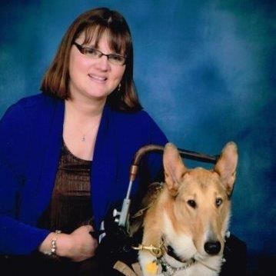
A Note from the Executive Director

Spring always brings new energy and excitement as the snow melts and flowers appear. This is an exciting time at CDK as well. More requests from schools and student groups (such as girl scouts and boy scouts) come asking for educational presentations to help their communities be aware and welcoming to service dog teams. I love these presentations. The genuine drive to make the world a better place and the curiosity to learn about those who are different makes each of these events unique and uplifting. Their desire to learn combined with your support of our programs means each presentation makes a community a bit more welcoming and supportive of service dogs and their human partners. Thank you for making life a little more welcoming and a little more independent every day for children with disabilities and their 4 legged tools, the trained service dogs who expand their world together.
Kristin and Asha

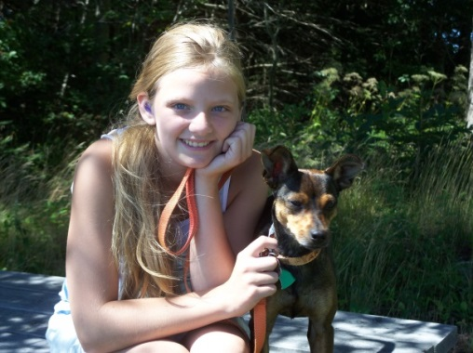
Reflecting about Snickers – by Emily

“I remember when I found out about hearing dogs. I thought it was a pretty cool thing to have and I begged my mom to get me one so I could wake myself up and try to hear things without her help. I also wanted a dog because my life was boring and lonely besides school and dance. There are not a lot of kids around my age that I can hang out with and hearing kids are so hard to understand. I was hoping that a dog would help keep me company. I imagined that it was going to make things better and I would not be so lonely.
Emily and service dog Snickers

When I brought Snickers home, I was happy but still I was nervous because I didn’t know how people were going to react. I didn’t know how easy or hard it was going to be. The easy part was that I knew how to give commands and make her obey me. The hard part was that I had to do it in front of people which made me nervous.

I think it has been both times of easy and hard things but mostly it is pretty good I have discovered more people want to be around me when I am with her. It’s plenty of fun to play with her. She always has a way to wake me up that makes me smile. She’s a smart dog that’s for sure. She can even tell when I’m sad and she seems to find a way to make me feel better.

In the morning I walk her with my dad and sometimes I am crabby because it is too early or too cold. I like to take walks at night with her and my older sister because it’s a way we can talk without any interruptions. Sometimes I wish I could change the time or give up my things to be with Snickers but I can’t. Some days it feels very hard. I think about how hard it is to be in school, work on my goals for acting, singing, and dancing and I just want to give up. I will feel for a moment like I wish I did not have Snickers. But things would be different without her. Now she is attached to a place in my heart that will not ever let her go, never ever, ever.”

Best Friends

According to the Urban Dictionary a “best friend” is “someone that you share your love of life, and makes you feel like you belong although your world around was chaos. Someone that you can laugh with despite the dire circumstances.

Seven year old Sadie will enthusiastically tell you that one of her “best friends” is Solar, her facilitated service dog. Sadie was diagnosed with autism as well as mitochondria disorder which affects cellular development and makes it difficult for her to walk. She has spasticity in her lower legs and muscle weakness in her upper legs and has never been able to walk completely independently. While Sadie wanted to be more independent, it was difficult to keep her safe at the same time.
Sadie and facilitated service dog Solar
Since having Solar, a Labradoodle, Sadie has gone from being in a wheel chair to a walker to now being able to walk beside her dog. “She no longer wants to be in her wheelchair.” says Sadie’s mom Nicki. “She always insists on walking with her "fluffy puppy". Sadie adds “The best part about Solar is taking him places.”

Solar helps support Sadie as she walks as well as braces her so she can get back to standing if she falls. In addition to assisting with Sadie’s mobility Solar is also strong at retrieving and picks up items Sadie drops to the ground. “Having Solar makes me think that maybe one day Sadie can be independent” says Nicki. “She has come a long way and Solar has been a big part of that.” “They’re just best friends”

Sadie, Mom Nicki and facilitated service dog Solar

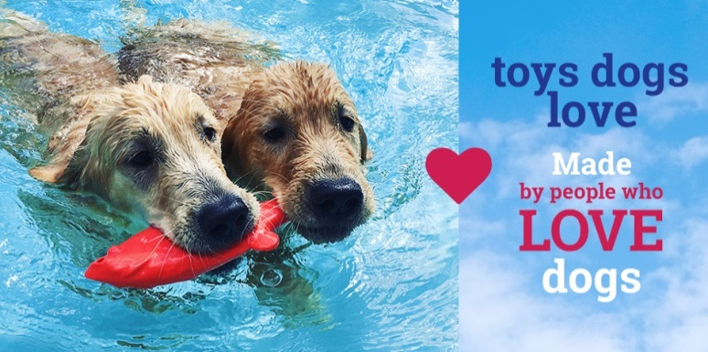
Shop for CDK Spotlight
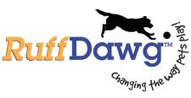
In August 2016, Ruff Dawg Toys became a valued sponsor of CDK’s mission. We are very grateful for their support and all of their assistance in increasing independence for children with disabilities through the use of service dogs.

Founded in 1999, Ruff Dawg Toys, a division of Jefferson Rubber Works, is a family owned business, headquartered in Worcester, MA, who manufacture a full line of durable rubber retrieving and chew toys for dogs. All of Ruff Dawg’s toys are
- Made 100% in the USA
- Non-Toxic
- Made of the highest quality, all FDA-Approved materials
- Free of toxic Phalates, Latex, and hormone disrupting BPA’s
- Designed to provide hours of safe & fun play!
For more information on the full line of Ruff Dawg products and where you can buy them go to http://ruffdawg.com/

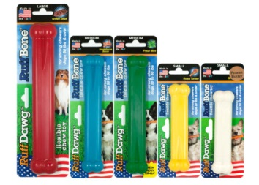

Chew Toys
Whipper Snapper

Fundraising Ideas to support CDK

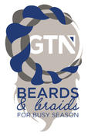
This month’s Fundraising Idea comes from our friends at Global Tax Network (GTN) which is based in Minneapolis, MN. GTN recently announced the launch of the annual Beards for Busy Season (BFBS) Campaign to help raise awareness and monetary support for CDK.
To date, the GTN BFBS campaign has raised nearly $5,000 in cash donations to help support nonprofit organizations.
This year, GTN refreshed the campaign by adding braids to the mix. Beards (& Braids) for Busy Season encourages everyone to not only grow their best beard possible, but to also braid their hair in new and fun ways in support of our fundraising efforts. The more creative, the better.
"Adding Braids to our BFBS Campaign will put a new spin on what we are accomplishing during this initiative and will open participation to more people," says Eric Loff, Managing Director for GTN's West Central region. "It's something fun we do as a team for a great cause."
This year's campaign will run through April 18, 2017, which represents the Internal Revenue Service's tax filing deadline in the United States. All GTN employees, families, and friends of the firm are encouraged to participate in this event by growing their beard or braiding their hair.
Employees are encouraged to go to the company’s special fundraising page to make a donation, follow the progress of BFBS on Twitter and to post pictures on Instagram. GTN’s goal is to raise $2,500 to support CDK “and creating independence for the children they support.”
About GTN (gtn.com) - While GTN’s specialty is mobility tax consulting and compliance, their story is a little different than the average tax accountant because GTN’s business thrives on the adventures of their clients. GTN works with globetrotters, world travelers, and international businessmen and women. Their mission is to support their client’s journey by handling the intricacies of the complex tax situations that may arise during their adventures. You could say GTN is able to take on what might seem like the weight of the mobility tax world for their clients and make it a little less intimidating.

Latest CDK Annual Report Now Available
The CDK Annual Report for FY2015 (September 1, 2015 – August 31, 2016) has recently been released.
Some highlights from that report:
Overhead: In FY 2015 CDK spent only 25% of our total revenue on overhead. This means 75 cents of every dollar received is spent on program services
Activities: In FY2015 CDK’s programs reached a total of 5,785 people in the following states: AR, AK, AZ, CA,CO, CT, Washington DC, FL, GA, HI, IA, IL, IN, KS, MA, MD, ME, MI, MN, NC, ND, NH, NJ, NM, NY, OH, PA, RI, TX, UT, VA, WA, WV
- Individual and Family Education Sessions: CDK had in person or phone meetings with 89 individuals or families to provide information and guidance in order to help connect them with a service dog
- School and Community Education and Awareness activities: We gave presentations at a total of 71 events, reaching 5,582 people to increase service dog understanding and make communities more welcoming
- Scholarships: A total $12,600 was awarded in scholarships to 23 children for their new service dogs.
Please contact us to request a copy of the full report.

CDK Calendar:

Date | Event Name | Location | Description
Apr 20 | Becker College Presentation | Becker College Leicester, MA | Educational talk Kristin and Asha
May 5 - 7 | NY Metro Abilities Expo | New Jersey Expo and Convention Center, Edison, NJ | Tom, Joanne and Millhouse will be at our booth. Kristin and Asha will be speaking
May 13 | 2017 Independent Living Expo | Fredericksburg, VA | Presentation and booth with Kristin and Asha
May 13 | Bridgewater Raritan H.S. Car Show | BRHS, Bridgewater, NJ | Car show to Benefit CDK
May 24 | Abilities Expo | Chicago, IL | Presentation and booth with Kristin and Asha
June 25 | It’s a Sweet Thing | Wormtown Brewery, Worcester, MA | Beer and Dessert pairing event to benefit CDK
Aug 6 | Succulent Terrarium Building Workshop | Seed to Stem, Worcester, MA | Build your own Succulent Terrarium to benefit CDK

