Summer 2017
Volume 2, Issue 4
CDK Independence Times

Your Impact - In Their Own Words

Thanks to you, children with disabilities are increasing their personal independence through the use of a service dog. The following are stories, written by two of those children, about how their service dogs have impacted their lives.

Erin and Roger
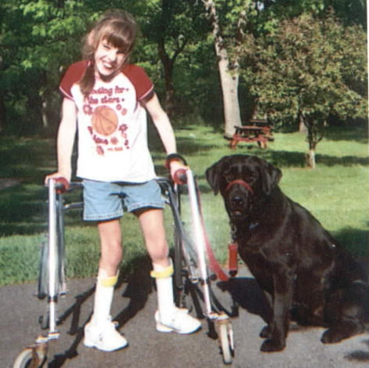
“Before Roger came, it felt like there was a big, blank space. Now that he’s here he can do things for me that I couldn’t do before. He helps me by shutting the lights on and off. He can fetch when I tell him to, then he’ll hold it. When I say “thank you” he gives it to me.
When he has his cape on and his gentle-leader, he knows its business. When we go to the Y, we say “leave it” so he won’t chase all the balls.
Roger goes everywhere with me because I need him. If he wasn’t there I wouldn’t do stuff. I lean on him to help me balance and he doesn’t mind. I can talk louder now because I had to practice my commands with him in training at the mall. Roger makes me feel glad because he’s my dog.”
Erin and service dog Roger
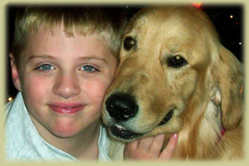
Matthew and Quincy
“My name is Matthew and I am 8 ½ years old. I have a really nice Assistance Dog named Quincy. He is the best companion that a kid could wish for. I love my dog because he helps me with a lot of things that sometimes I can't control. Sometimes I'm crying in a crowd and Quincy helps me a ton by licking and kissing me so I feel better. He helps me talk to people. Canines for Disabled Kids helped me a lot by getting me this very special dog."
Matthew and service dog Quincy
Matt has Asperger's Syndrome which makes it difficult for him to process the world, both on social and sensory levels. Some of the tasks that Quincy was specially trained for include providing assistance to Matt in calming himself when stressed, interacting in public, and task adherence. Your donations to Canines for Disabled provided a scholarship to Matthew that resulted in Matt and his Mom, Ann, graduating from "doggie college"
Recognition and Appreciation for All They Do

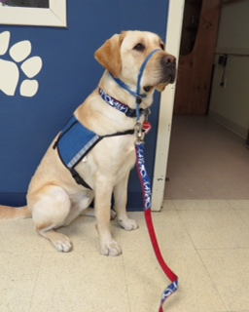
International Assistance Dog Week (IADW), August 6 – 12, 2017, recognizes all of the devoted, hardworking assistance dogs helping individuals mitigate their disability-related limitations.
Assistance dogs transform the lives of their human partners with debilitating physical and mental disabilities by serving as their companion, helper, aide, best friend and close member of their family.
There are many different kinds of assistance dogs, from the well-known guide dogs and hearing alert dogs that help people with vision and hearing loss, to lesser-known helpers like seizure alert and medical alert dogs that can recognize the signs of heart attacks, strokes and epilepsy
Service Dog Hunter

IADW recognizes and honors assistance dogs, their trainers and those who place them with their human partners, and aims to educate the public and increase awareness of the work they do.

Pet first-aid kit: 8 things every pet owner should keep on hand

By JoAnne Viviano, More Content Now

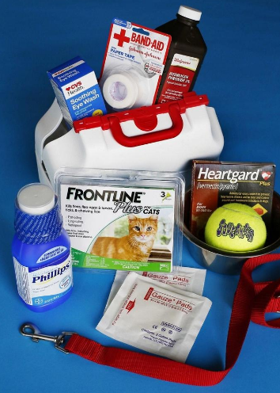
The key to a healthy pet is to see a veterinarian at least once a year and stay up to date on appropriate vaccinations, including those that protect against rabies for dogs and upper respiratory infections in cats, said Dr. Robert Knapp of Knapp Veterinary Hospital in Clintonville.
Photo/Fred Squillante/Columbus Dispatch

But there are some eight things you should keep on hand at home:

1. Prescription heartworm prevention: Protect your pet against this potentially fatal disease, which is caused by worms in the heart, lungs and certain blood vessels.

2. Prescription flea and tick prevention: It’s also important for preventing diseases that can be fatal.

3. Gauze bandages and adhesive tape: These can cover cuts or wounds until you can get to an veterinary emergency department.

4. Milk of magnesia: This can absorb poisons eaten by a pet. Always contact your veterinarian before using.

5. Hydrogen peroxide: This can induce vomiting if a pet eats something it shouldn’t. Always contact your veterinarian before using.

6. Over-the-counter eyewash: It’s safe to use if your pet is squinting a lot or has dust in his or her eyes.

7. Water: Pets should have free access to water at all times, unless there is a medical reason to limit it.

8. Exercise: Remember not to overdo it. Pets might need to get conditioned in the spring if they’ve spent most of the winter sitting on the couch.

“Pets have to get acclimated, too. Sometimes we forget pets haven’t been as active, and we need to work our way up to that,” Knapp said.

Should you use antihistamines and other over-the counter medications? It depends, so you should ask your vet.

Keep in mind that some medications that are safe for humans are not safe for animals. For example, acetaminophen, the drug in Tylenol, can be fatal to cats, Knapp said. And some flavorings and sweeteners can also be toxic to pets.

“Just because it’s OK for us doesn’t mean it’s OK for pets,” Knapp said.

Additional Dog Healthcare Resources:

Resource | Description | Phone | Website
ASPCA Animal Poison Control Center | 24 hours a day, 365 days a year. Call if you think your pet may have ingested a potentially poisonous substance. A $65 consultation fee may be applied to your credit card. | (888) 426-4435 | https://www.aspca.org/pet-care/animal-poison-control
"Dog First Aid"  Book and DVD | A valuable resource for dog owners from the American Red Cross. $17 | n/a | https://www.redcrossstore.org/item/657780
WebMD | Dog Health Symptoms A - Z | n/a | http://pets.webmd.com/dogs/symptoms

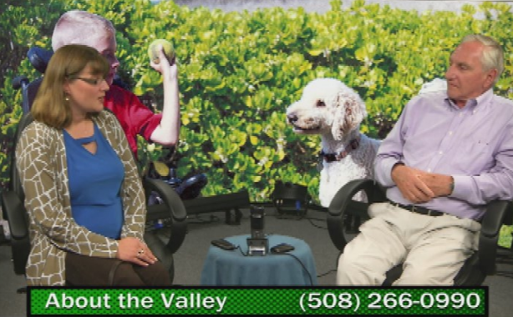
Kristin Interviewed on “About the Valley”
Kristin talking with Harry Berkowitz
CDK Executive Director Kristin Hartness recently appeared on “About the Valley” a weekly show hosted by local celebrity Harry Berkowitz on NCTV-11.

The informative 60 minute interview covered a wide variety of topics including how service dogs are trained and matched with their person, the growth in the number of disabilities a service dog can be trained to assist and reasons why service dogs increase independence for children with disabilities. To see the entire interview please go to: https://caninesforkids.org/northbridge-ma-cable-tv-interview/
Which do you prefer, beer or dessert?
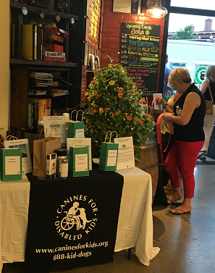
For the past eight years CDK has held a fundraising event so people do not have to choose.

“Incredible Pairings – A Beer and Dessert Fundraising Event” is CDK’s annual spring fundraiser to benefit “connecting children with disabilities to service dogs.”

This year’s event was held June 25th at Wormtown Brewery in Worcester, MA. The highlight of the evening is the pairing of three creatively flavorful craft beers from the award winning Wormtown Brewery with three decadently delicious desserts from Chef Alina Eisenhauer, who has appeared on numerous Food Network shows, and owns Sweet Kitchen & Bar.
Raffle at CDK's Pairing Event

Thanks to our event sponsors, advertisers, raffle donors and attendees, the 2017 version of “Incredible Pairings” was our most successful yet. We greatly appreciate everyone’s support of the event and for increasing independence for children with disabilities through the use of service dogs.

Watching is Giving!

Advertisers need people to watch their ads. That’s never going to change. But what people get out of watching ads can change. And it starts with you. By using AdWap, you can donate money to charities you care about, and convert your down time to cash! AdWap turns the mindless routine of watching ads into a mindful activity that can change lives.
How it Works
- You download the app or visit the website and create an account (It’s free)
- You choose a charity to support (Hint – Canines for Disabled Kids)
- You spend no more than 5 minutes a day watching up to 10 short ads (tailored to your interests)
- Each view triggers a donation to your charity (Hopefully Canines for Disabled Kids)
- Each view equals an entry into a daily cash giveaway
- You wait to hear if you won the daily drawing.

So if you, or someone you know, are a little tight on cash and have a few minutes to spare, AdWap gives you the opportunity to donate to your favorite charity while getting a chance to win some cash at the same time. For more information go to https://www.myadwap.com/home

CDK Calendar:
Date | Event Name | Location | Description
Jul 11 | Tufts AVM (Adventures in Veterinary Medicine) | Grafton, MA | Educational talk by Mallory and Jozsi
Jul 18 | Worcester Commission for Disabilities | Worcester, MA | Presentation by Kristin and Asha
Aug 2 - 4 | Focus Foundation 14th Annual 49er Conf. | Annapolis, MD | Presentation by Mallory and Jozsi
Aug 4 - 6 | Abilities Expo | Houston, TX | Presentation and booth with Kristin and Asha
Aug 6 | Build your own Terrarium | Worcester, MA | Event to benefit CDK at “Seed to Stem”
Aug 6 - 12 | International Assistance Dog Week | Everywhere! | Recognizes the hardworking assistance dogs who help individuals mitigate their disability-related limitations
Sept 8 - 10 | Abilities Expo | Boston, MA | Presentation and booth with Mallory and Jozsi
Sept 9 | NYC Emergency Management Conf. | Staten Island, NY | Presentation by Kristin and Asha

For additional information please go to: https://caninesforkids.org/category/events/

