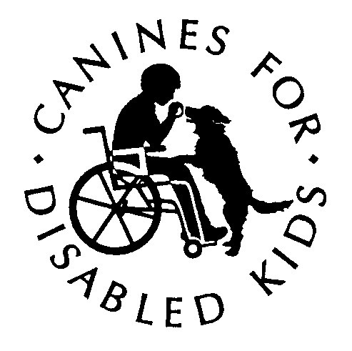
Flavorful Craft Beers & Decadent Desserts
Children with Disabilities & Service Dogs

Incredible Pairings
A Beer and Dessert Fundraising Event
Sunday June 25, 2016 • Wormtown Brewery • 72 Shrewsbury Street • Worcester, MA
Partner With Us
Independence…, the freedom to make choices…, to do what we want, when we want to do it.
For children with disabilities independence comes with four legs, a cold nose and unconditional love. Opening doors, turning on a light, picking up dropped items or hearing a loved one call your name are just a few ways service dogs bring independence to people living with disabilities.
Canines for Disabled Kids, a 501(C)(3) nonprofit organization headquartered in Worcester, is a unique resource tool for national information and services related to service dogs and their roles with children with disabilities providing:
- Personalized information and guidance to help connect families with the right service dog training program for their child,
- Educational programs for schools, business and other community organizations which makes communities more welcoming and accessible to service dog teams.
- Scholarships to help offset the cost of training a service dog.
All at no cost to the family or the community.

We believe that much can be achieved through thoughtful collaborations with corporate and community organizations. A sponsorship of “Incredible Pairings” provides a meaningful way to support the important services we provide and features benefits that showcase your organization’s brand and communicates your values and willingness to help accomplish our mission.

Please join us!

(over→)
Facts about Canines for Disabled Kids

Canines for Disabled Kids (CDK)
- Founded in March 1998
- Headquartered in Worcester, MA

CDK is a 501(c)(3) nonprofit organization.
- Our Tax ID number (or EIN) is 04-3412812

Mission
- To increase independence for children with disabilities and their families through the use of a service dig by creating partnerships, awareness and understanding.

Vision
- To be the preeminent resource for information and services pertaining to service dogs and their roles related to individuals with disabilities

Programs
- Personalized information and guidance to help connect families with the right service dog training program for their child,
- Educational programs for schools, business and other community organizations which makes communities more welcoming and accessible to service dog teams.
- Scholarships to help offset the cost of training a service dog.

Finances
- CDK received donations of $146,000 last year
- 75% of that money went to programs that directly furthered our mission

Impact
- That money allowed our programs to reach 5,403 people
- Provided guidance and assistance for 124 families
- Conducted 264 private consulting sessions
- Gave educational talks to 65 groups
- Awarded 23 scholarships totaling $9,500
- Exhibited at 18 Trade Fairs and Abilities Expos around the country

Cost of our programs to the individual and community
- $0
Sponsorship Opportunities
Platinum Sponsor Contribution = $750
Benefits
- Full page ad in the 2017 Incredible Pairings program
- Premium seating for six (6)
- Recognition on CDK’s Facebook with link to sponsors web site seven times
- Recognition on the CDK website with link to sponsors web site for 90 days
- Personal recognition as a sponsor during opening and closing remarks
Gold Sponsor Contribution = $500
Benefits
- Half page ad in the 2017 Incredible Pairings program
- Premium seating for four (4)
- Recognition on CDK’s Facebook with link to sponsors website five times
- Recognition on the CDK website with link to sponsors web site for 90 days
- Personal recognition as a sponsor during opening and closing remarks
Silver Sponsor Contribution = $250
Benefits
- Third of a page ad in the 2017 Incredible Pairings program
- Premium seating for two (2)
- Recognition on CDK’s Facebook with link to sponsors web site two times
- Recognition on the CDK website with link to sponsors web site for 90 days
- Personal recognition as a sponsor during opening and closing remarks

(over→)
Advertising Opportunities
Ad placement in the 2017” Incredible Pairings” Program
Full Page Ad = $150 Half Page Ad = $100 One Third Page Ad = $75

Half Page
4 ¾” x 5 ½”
One Third Page
2.375” x 5 ½”

Full Page
8 ½” x 5 ½”

Impressions of Deliverables
Deliverables | Impressions
CDK Website mention | 4,922 Users / 5,733 Sessions
CDK Facebook mention | 3,869 Followers
Event Program | 60
Verbal Thank you | 120
Event Signage | 120

Past Event Attendee Demographics
Age:
20's and 30's 11%
40's and 50's 61%
60's plus 27%

Gender:
Female 55%
Male 45%
(over→)

Sponsorship/Ad Registration Form
Company
Contact Name
Address:
City: State: Zip
email:
Work Phone Cell Phone:
Please Indicate Your Sponsorship Level and/or Advertising

Platinum $750
Gold $500
Silver $250
Full Page $150
Half Page $100
One Third Page $75

Please call 978.422.5299 for more information

Sponsorship and Advertising Deadline
In order to ensure we are able to include you or your organization in the program, please return this completed form along with your ad and/or a high resolution jpg of your logo by June 12, 2016 to info@caninesforkids.org

(over→)
Incredible Pairings
A Beer and Dessert Fundraising Event
Sunday June 25, 2016 • Wormtown Brewery • 72 Shrewsbury Street • Worcester, MA
It is Easy to Participate
Payment Options
Check
Please make the check payable to Canines for Disabled Kids and Mail to:
Canines for Disabled Kids
255 Park Ave
Worcester, MA 01609
Credit Card
Donation can be made with a credit card by calling 978.422.5299 or by going to our website www.caninesforkids.org and clicking the “Donate” tab
Visa, Master Card, American Express and Discover are accepted

All gifts payable to Canines for Disabled Kids are tax deductible to the extent allowed by federal and state laws

CDK’s Federal Tax ID number is 04-3412812

Thank you for your support!

